**Assignment – 2: Central Tendency**

**The following table shows the Mean, Median, and Mode of the Placement dataset.**

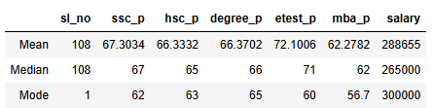

**Results / Observations**

* **In ssc_p, hsc_p, degree_p, and mba_p, the students scored an average of around 66%, which**
* **indicates average performance.**
* **In etest_p, the mean score is 72%, which is higher and can be considered a good category. Overall, the class can be categorized as average performers.**
* **The mean salary is ₹2,88,655, whereas the median salary is ₹2,65,000. Since the median is**

**Less than the mean, this indicates the presence of outliers in the salary distribution.**

**The most frequently occurring (mode) values are:**

**ssc_p = 62%**

**hsc_p = 63%**

**degree_p = 65%**

**mba_p = 56.7%**

**salary = ₹3,00,000**

**This shows that while most academic scores cluster around the mid-60s, the etest_p stands out with higher performance, and the salary distribution is skewed due to outliers.**